**INTRODUCTION**

**1.INTRODUCTION**

The Basic necessity of security can be attained by designing various door locks such as mechanical locks or electrical locks. These kind of door locks are designed with one or more keys, but for locking a large area various locks are needed. Generally, traditional locks are heavy and that are not strong as they can damage simply by using some tools. [Electronic locks](https://www.elprocus.com/password-based-electronic-lock-system/) are better over mechanical locks, to resolve the security problems that are connected with the mechanical locks. In recent days every device uses digital technology. For example, identification of digital device using token, door lock system using digital technology, automatic door opening and closing, automatic door lock systems, etc. These kinds of systems is used for controlling the movement of a door without using a key.

* 1. **INTRODUCTION**

**RADIO FREQUENCY IDENTIFICATION**

Radio Frequency Identification (RFID) is a prominent technology for a wide array of applications, from inventory tracking to payment processing. When it comes to security, RFID door lock systems are very common for access control, as they provide a reliable, consistent experience with trackable data. Unlike other forms of traditional access control such as Swipe Cards, RFID locking systems are contactless, meaning that the credential doesn’t have to touch the reader for it to work.

Similar to barcode readers, RFID readers work by sending and receiving data, but instead of having to scan a code, the data is transmitted over radio frequencies. An RFID Door Locking System requires RFID tags, antennas, an RFID Reader and a transceiver in order to function as a complete system.

In an RFID door lock access control system, the user’s control the user’s credential contains unique identifying information called a tag. When the user comes within proximity of a reader, the reader’s signal locates the information stored on the user’s RFID tag, and sends it through antennas and transceivers to authorize the tag in the access control system. Once read, the system will either accept or deny the request to unlock the door. Data from an RFID enabled system is automatically stored, making it possible to track entry in an access control system.

Radio Frequency Identification (RFID) Card Readers provide a low-cost solution to read passive RFID transponder tags up to 2 inches away. The RFID Card Readers can be used in a wide variety of hobbyist and commercial applications, including access control, automatic identification, robotics navigation, inventory tracking, payment systems, and car immobilization. The RFID card reader read the RFID tag in range and outputs unique identification code of the tag at baud rate of 9600. The data from RFID reader can be interfaced to be read by microcontroller or PC. In this project, the RFID module reader typically contains a module (transmitter and receiver), a control unit and a coupling element (antenna). This module is interfaced with the micro controller and when the card is brought near to the RFID module, it reads the data in the card and displays on the LCD. If the data in the card is matched with the data stored in the program memory, then it compares and displays authorized message. If the data is not matched it displays unauthorized. For authorized message, the door will be opened and closes automatically after a small delay. If it is an unauthorized person it alerts the persons through a buzzer. The RFID module alerts the buzzer whenever it reads the data from the RFID card. The door will drive by DC gear motor by l293d driver. The significant advantage of all types of RFID systems is the non contact, non-line-of-sight nature of the technology. Tags can be read through a variety of substances such as snow, fog, ice, paint, crusted grime, and other visually and environmentally challenging conditions, where barcodes or other optically read technologies would be useless. This project can provide security for the industries, companies, etc. In this project 7805 is a regulator and it avoids noise spikes in power supply. RFID modem is connected microcontroller through serial port. These RFID modem works under 9600 or 4800 baud rates. 16X2 LCD connected to microcontroller through digital I/O lines.

RFID Door Lock Access Control is relatively secured in comparison to conventional mechanical locks or traditional locks and also installation of RFID based locks is very easy and cost effective.

* 1. **OBJECTIVE OF THE PROJECT**

The main goal of this project is to create a more convenient way to unlock your door than the traditional key. In the place of a key, there is an RFID tag that will unlock the door.

As said earlier, RFID based locks provide higher security than conventional locks.

**PROPOSED SYSTEM**

The actual working of the system starts when a user holds an RFID tag card over the EM-18 reader. The reader tries to scan the card. There is a possibility that the card help by the user is not an RFID tag but something else like id card, college card, atm card, etc. In that case the RFID reader is not able to recognize the card. If the card is to be an RFID tag, the scanner receives the12 digit number from the tag and then passes on to the microcontroller i.e. Nose MCU. Once the scanning is done a buzzing sound is made to notify the user that the card has been scanned. Based on the code installed, the microcontroller either recognizes the tag number or it doesn’t. If the tag number is not in the code it sends a signal to the LCD to display that the user is invalid. Also the system alarms thru the buzzer, notifying that the card is invalid. If the tag number is present in the code, LCD displays the User details and the card number on the screen. The servo motor is then signaled and it is rotated in order to open the door. After few seconds the motor is rotated back to close the door again. Then the microcontroller runs the script to send the data on web. While the data is being uploaded, the LCD displays “Uploading on Web”. Using the API key of the Thing Speak account, the microcontroller sends the data to the server. The received data is used to get a visualization. The visualization depicts when and which user had accessed the door. After successful uploading the data on web (after 18 seconds) the system is ready for scanning next tag. According to International Journal of Computer and Electrical Engineering, Vol.3, No.1, February, 2011, the paper gave an overview of the current state and trends of RFID technology. Even though numerous limitations and unresolved issues still hinder the widespread application of RFID. Despite these challenges, RFID continues to make inroads into inventory control systems, and it’s only a matter of time before the component costs fall low enough to make RFID an attractive economic proposition. Furthermore, extensive engineering efforts are under way to overcome current technical limitations and to build accurate and reliable tag reading systems. We might also start to see economic pressure from the larger distributors to modify product packaging and its associated materials to more effectively integrate RFID. Finally, at this delicate stage, while major corporations are trialing the technology, media reaction and outspoken privacy groups can influence the rules by which we use the technology. RFID’s potential benefits are large, and we’re sure to see many novel applications n the future—some of which we can’t even begin to imagine. The components that go into RFID readers and tags are simple radio communications, but their smaller size and broad deployment enhance the power of the technology and raise concerns about the privacy effects of RFID deployment. These concerns are often premised on unlikely assumptions about where the technology will go and how it will be used.

**1.3 ORGANIZATION OF THE REPORT**

The report includes the stepwise implementation of the working prototype and it describes the overview of how effectively the project can be implemented and allows the viewer of the report to get an overview and accurate understanding of the project. The following is an overview of each chapter that is included in this documentation .

* Chapter 1 deals with the Introduction of the Project.
* Chapter 2 includes the system Specifications where we can get clarity on the hardware and software specifications.
* Chapter 3 includes the design and implementation of the project including the hardware connections and software set up. It also includes the source code that can be implemented for the desired output.
* In chapter 3 we also include the output screens which would make readers easy to understand and are free from ambiguity.
* Chapter 4 includes the conclusion part where we conclude how the prototype works in whole such that a normal reader can also understand the significance of the prototype and why it is to be used.
* At last the references are placed from where we had brought the information and idea on developing the project.
  1. **CUSTOMER NEEDS ASSESSMENT**

As stated before, the improvements must outweigh the complications of implementation. There has to be a reason to buy this door lock and replace their own door locks with it. That is why convenience and reliability are the first two customer needs. These are possibly the most important and apply to almost every engineering specification and do not require as much explanation as the other three. One of the more interesting requirements is the hassle-free installation. Of course the door lock will require minor assembly but the process of installation should not be overly complicated. The device should be a complex system simplified for the common consumer. Another important feature is the need for failsafes and overrides. In cases where the owner may lose their keys, the owner of the door lock should not be denied access to the door at any time. There should always be a way in that is only accessible to the customer. These needs are listed in Table 1.

The requirements and specifications were generated with the customer needs as a basis. These specifications are listed in Table 1. To the left of the Engineering Specifications are the Customer Needs that each specification meets. The justification on right details the thinking and reasoning behind the specifications and how they fit the customer needs.

**CUSTOMER NEEDS**

1. Needs to be convenient so that people will have an easier time unlocking their doors .

2. Needs to be reliable so that people can trust the door lock.

3. Hassle-free to install so that anyone can install it into their home with ease.

4. Failsafe and overrides in case the RFID key is lost or the power fails.

**TABLE 1**

**RFID SECURITY DOOR LOCK REQUIREMENTS AND SPECIFICATIONS**

|  |  |  |
| --- | --- | --- |
| **Customer Needs** | **Engineering Specifications** | **Justification** |
| **1** | Unlocks door in the presence of RFID within 20cm. | This will make the door easier to unlock than a regular key. |
| **2,3** | The physical door lock should be thinner than the doorframe. | This way the door lock will be hidden and avoid external tampering. |
| **1,3** | Should be easy enough to install in 5 steps maximum. | Simple enough for anyone to install. |
| **1,2** | The lock should be powered by a 9V source so that it can run on 9V batteries as a backup. | This is a common voltage to find within a house Customer Needs 1. Needs to be convenient so that people will have an easier time unlocking their door. |

**SYSTEM REQUIREMENTS**

**2.SYSTEM SPECIFICATIONS**

**2.1 SOFTWARE REQUIREMENTS**

The software specifications that we used for the implementation of this project are as follows:

• Operating System : Windows 10

• Coding Language : C/C++

• Development Environment : Arduino IDE

**2.2 HARDWARE SPECIFICATIONS**

The hardware specifications used for the implementation of this project are as follows:

* Arduino UNO
* Bread Board
* Jumper Wires
* RFID Module
* Servos
* LED’s
* Buzzer

**2.1 SOFTWARE REQUIREMENTS**

**2.1.1 Arduino IDE**

The Arduino IDE is used for running the code of working model.

Operating Systems supported by Arduino IDE are: **Windows, macOS** and **Linux.**

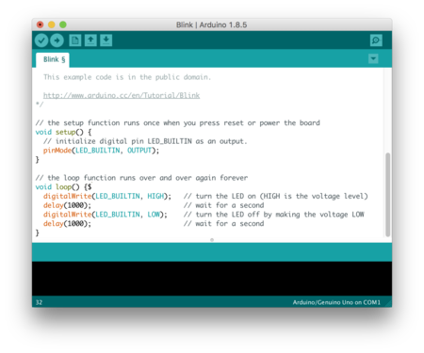

Fig 2.1.1.1 Arduino IDE

**2.1.2 LIBRARY REQUIREMENTS**

**●RFID.h**

This library is used for including both RFID Tags and Readers.

**●SPI.h**

It is special serial interface between Hardware and Software.

**●LiquidCrystal.h**

It is a special library to include the LCD Display.

**●Servo.h**

Servo.h to include servo machine.

**2.2 HARDWARE REQUIREMENTS**

The framework dependent on this model is introduced at the passage of the restricted room. In this created work, we require the RFID Module, RFID tag, and servo engine to see the controlling framework. It could utilize a minimized hardware worked around the Arduino UNO board. The project could be created in embedded C++. The segments required in the model are as follows:

**2.2.1 ARDUINO UNO**

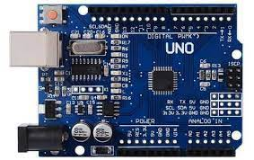

**2.2.1.1 Arduino Uno**

Arduino Uno is an open source microcontroller board developed by Arduino.cc. It is a small development board having size 2.7 in * 2.1 in. It is both highly hardware and software compatible.

Arduino UNO is a microcontroller board based on the **ATmega328P.** It has 14 digital input/output pins where 6 pins can be as Pulse Wave Modulating (PWM) outputs, 6 analog inputs, a 16 MHz ceramic resonator, a USB connection, a power jack, an ICSP header and a reset button.

It contains everything needed to support the microcontroller; simply connect it to a computer with a USB cable or power it with a AC – to – DC adapter or battery to get started.Arduino Uno is very small when compared to Arduino Mega but it is good for small developmental projects and prototyping. Its less cost and features makes it a good choice among engineers and students for project development.

**2.2.2 RFID MODULE**

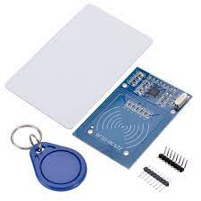

**Fig 2.2.2.2 RFID Module**

RFID is contracted as Radio Frequency Identification. It makes a remote correspondence and empowers information move between RFID tag and RFID reader. This module can read and compose information without direct contact. The RFID label comprises of kilobytes of rich data in it. The RFID reader is a functioning segment .The RFID tag, then again, is a detached segment that is situated on the item we need to distinguish. It has an antenna attached to a microchip. So as we place the tag is near the scope of RFID reader than some voltage is created in reception apparatus curl and voltage act as power. In our work, we have utilized RC522 MODULE to get to door control framework.

When the tag is placed in the proximity of the reader, Electro Magnetic Induction phenomenon takes place and as a result the electric field also passed through the tag.

Then, both the tag and reader emit Radio Frequencies. If both the frequencies are matched, then the Access is granted or else the Access is rejected.

RFID Reader is attached to the Arduino Uno and it gets the power supply from Arduino Uno Board. This current RFID module attributes to contactless door unlocking system.

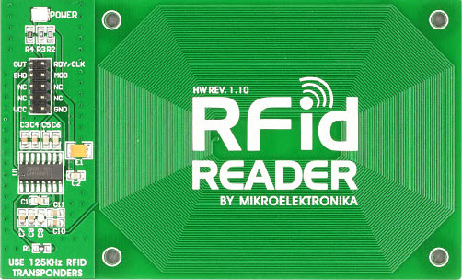

**Fig 2.2.2.3 RFID Reader**

**2.2.3 SERVOS**

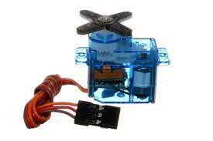

**Fig 2.2.3.1 Servos**

Servos or generally called as Servo Motors are used for radio control and small scale robotics. They are usually small and cheap. They serve as actuators.

A servomotor controls the angular position, speed, and acceleration. It comprises of a reasonable engine coupled to a sensor for position feedback . Servomotors have various applications in the field of mechanical autonomy, computerized producing and so on. Engine in our work is to open and close the door consequently when the RFID per user recognizes the RFID tag of the client.

The rotor in the Servos turns 180 degrees when the Access is granted indicating the opening of the door and remains as it is when the Access is denied.

**2.2.4 JUMPER WIRES**

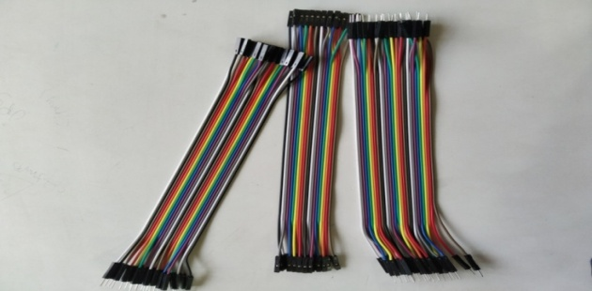

**Fig 2.2.4.1 Jumper Wires**

Jumper links are utilized to move electric flow from one point to other inside a circuit. Because of high conductivity, jumper links are made of copper and aluminum. In this model, we have utilized three mix of jumper link for example male to male, female to female and male to female.

**2.2.5 LIGHT EMITTING DIODES**



**Fig 2.2.5.1 LED**

A light emitting diode is a diode that produces visible light when an electric current goes through it. They are profoundly effective and produces monochromatic light. Here LED’s are used to show the status of the Circuit.

**2.2.6 BUZZER**

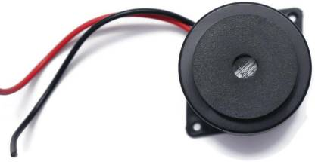

**Fig 2.2.6.1 Buzzer**

It is a two pin device which gives sound component to our work. The piezo signal produces sound dependent on the switch of the piezoelectric impact. In our work, we have utilized a buzzer. The Buzzer makes some sort of sound whenever the access is denied. In general, the Buzzer is used to indicate the authorization of the RFID Tags placed near the RFID Readers.

**2.2.7 BREAD BOARD**

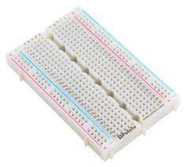

**Fig 2.2.7.1 Bread Board**

A **breadboard** is an electronic tool which can be used to test electrical circuits. Instead of using [soldering](https://simple.wikipedia.org/wiki/Soldering) to connect wires and components together (like on a [perfboard](https://simple.wikipedia.org/w/index.php?title=Perfboard&action=edit&redlink=1" \o "Perfboard (not yet started)) or [printed circuit board](https://simple.wikipedia.org/wiki/Printed_circuit_board)), they can be stuck into the holes of the breadboard. It has metal strips inside that will connect them, and it lets them be removed easily or moved around when testing a circuit.

The rows and columns of holes on a breadboard are usually labelled with numbers and letters. Everything in a row with the same number will be connected, except if the breadboard has a strip down the center. In that case, the metal is split and the row has two separate connections (one on each side). The center strip is also useful when connecting [integrated circuit](https://simple.wikipedia.org/wiki/Integrated_circuit)s, because they can be pushed in over the top of it and have legs connecting to both sides without overlapping the connections.

22 or 24 gauge wire usually work best to plug into the holes in a breadboard.

**2.2.8 LCD**

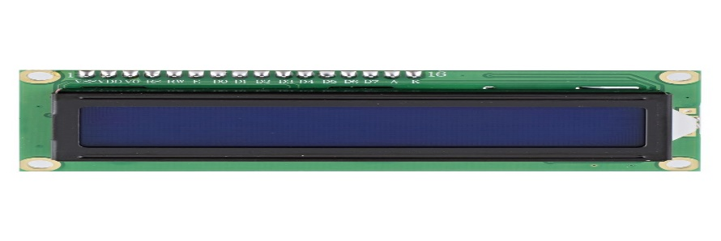

**Fig 2.2.8.1 LCD**

The LCD is used to show the output of the Whole System. If the Access is granted, it prints

“Access Granted” on the LCD Screen or else it prints “Access Denied” on the LCD Screen.

**DESIGN AND IMPLEMENTATION**

**3.DESIGN AND IMPLEMENTATION**

**3.1 INTRODUCTION**

[Arduino is a microcontroller board](https://www.elprocus.com/arduino-basics-and-design/) based on the Atmega family. It consist of 14 digital I/O pins. An Arduino board includes 6 analog i/ps, a USB, a reset button, an ICSP header a 16 Hz quartz crystal, and a power jack. It covers everything desired to support the microcontroller. It is simply connected to a computer with a USB cable and It is interfaced with RFID Module.

**PIN STRUCTURE OF ARDUINO UNO**

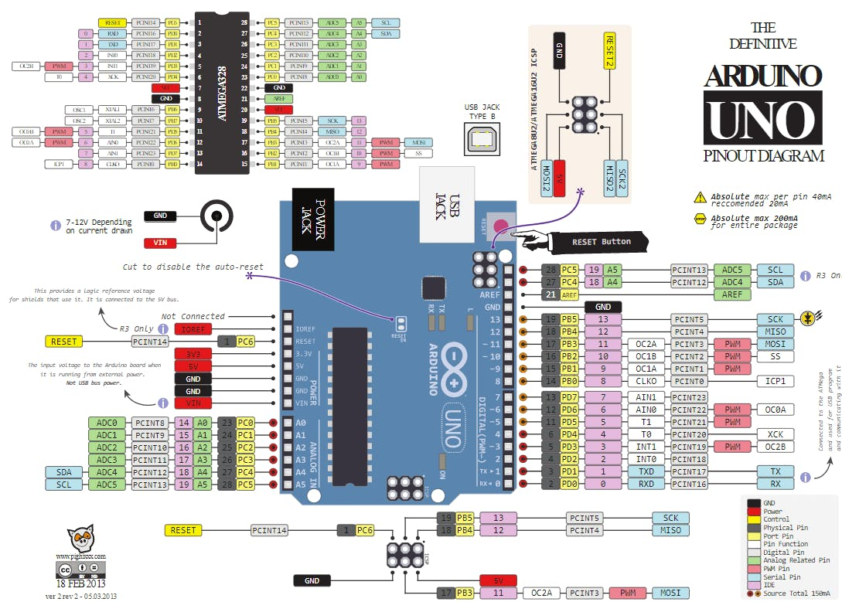

**Fig 3.1.1 Pin Structure**

**Vin:**This is the input voltage pin of the Arduino board used to provide input supply from an external power source.

**5V:**This pin of the Arduino board is used as a regulated power supply voltage and it is used to give supply to the board as well as onboard components.

**3.3V:** This pin of the board is used to provide a supply of 3.3V which is generated from a voltage regulator on the board.

**GND:** This pin of the board is used to ground the Arduino board.

**Reset:** This pin of the board is used to reset the microcontroller. It is used to Resets the microcontroller.

**Analog Pins:**The pins A0 to A5 are used as an analog input and it is in the range of 0-5V.

**Digital Pins:**The pins 0 to 13 are used as a digital input or output for the Arduino board.

**Serial Pins:** These pins are also known as a UART pin. It is used for communication between the Arduino board and a computer or other devices. The transmitter pin number 1 and receiver pin number 0 is used to transmit and receive the data resp.

**External Interrupt Pins:** This pin of the Arduino board is used to produce the External interrupt and it is done by pin numbers 2 and 3.

**PWM Pins:** This pins of the board is used to convert the digital signal into an analog by varying the width of the Pulse. The pin numbers 3,5,6,9,10 and 11 are used as a PWM pin.

**SPI Pins:** This is the Serial Peripheral Interface pin, it is used to maintain SPI communication with the help of the SPI library. SPI pins include:

1. SS: Pin number 10 is used as a Slave Select
2. MOSI: Pin number 11 is used as a Master Out Slave In
3. MISO: Pin number 12 is used as a Master In Slave Out
4. SCK: Pin number 13 is used as a Serial Clock

**LED Pin:**  The board has an inbuilt LED using digital pin-13. The LED glows only when the digital pin becomes high.

**AREF Pin:** This is an analog reference pin of the Arduino board. It is used to provide a reference voltage from an external power supply.

**ELECTROMAGNETIC INDUCTION IN RFID**

RFID uses the process of Electromagnetic Induction in the process of identifying or validating the tags. Electromagnetic Induction or Induction is a process in which a [conductor](https://www.toppr.com/guides/physics/electric-charges-and-fields/conductors-and-insulators/) is put in a particular position and magnetic field keeps varying or [magnetic field](https://www.toppr.com/guides/magnetic-effects-of-electric-current/magnetic-field-and-magnetic-force/) is stationary and a conductor is moving. This produces a Voltage or  EMF (Electromotive Force) across the electrical conductor.

This either happens when a conductor is set in a moving magnetic field (when utilizing AC power source) or when a conductor is always moving in a stationary magnetic field. This law of electromagnetic induction was found by **Michael Faraday.** He organized a leading wire according to the setup given underneath, connected to a gadget to gauge the voltage over the circuit. So when a bar magnet passes through the snaking, the voltage is measured in the circuit. The importance of this is a way of producing electrical energy in a circuit by using magnetic fields and not just batteries anymore. The machines like generators,  transformers also the motors work on the principle of electromagnetic induction.

**FARADAY’S LAWS OF ELECTROMAGNETIC INDUCTION**

First law:  Whenever a conductor is placed in a varying magnetic field, EMF induces and this emf is called an induced emf and if the conductor is a closed circuit than the induced current flows through it.

Second law: The magnitude of the induced EMF is equal to the rate of change of flux linkages.

Based on his experiments we now have Faraday’s law of electromagnetic induction according to which the amount of voltage induced in a coil is proportional to the number of turns and the changing magnetic field of the coil.

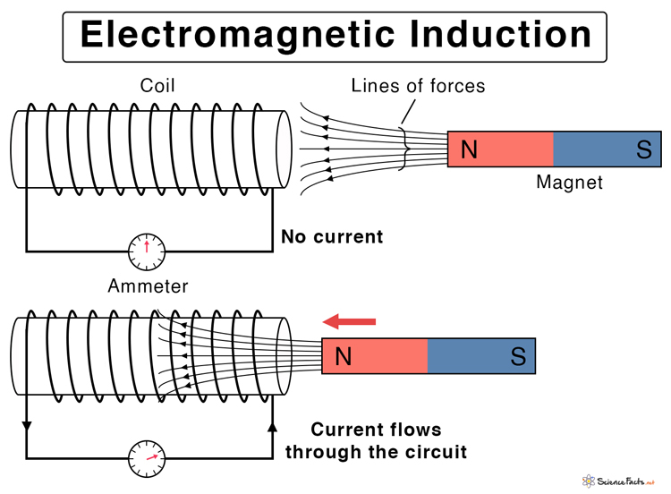

**Fig 3.1.2 EMI**

**INTERFACING OF RFID READER WITH ARDUINO**

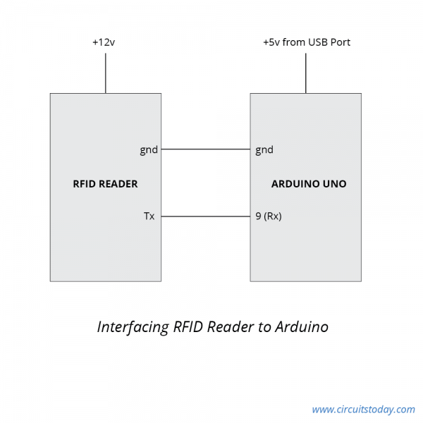

**Fig 3.1.3 Interfacing**

The necessity of power supply for RFID readers varies from one product to another. There are many RFID readers are available in the market with 5v, 9v and 12v. But, here a 12v RFID reader is used for an interfacing. You may confirm the RFID reader and [RFID tags](https://www.elprocus.com/rfid-tags-applications/)are frequency compatible

RFID gives mainly two possible outputs, one is TTL compatible o/p and another one directly. While the output pin of an RS232 compatible must be changed to TTL using an RS232 to TTL converter.

The automatic door lock system circuit diagram using an Arduino is shown below. This circuit is mainly used for an interfacing of RFID reader with an Arduino. This project can be enhanced by connecting an [LCD display](https://www.elprocus.com/ever-wondered-lcd-works/) to display the outputs. The circuit of this project uses three separate parts, namely a reader, a controller and door lock. Where a reader reads the RFID tags, a controller is used to accept the data from the RFID reader and control the o/p of the door lock and RGB LED.

When the door lock is placed on a door and tested with a battery to check the installation. In many cases we need a simple circuit on the door lock, that means the automatic door stops locked when there is no flow of current. When 12 volts DC is supplied through the electromagnet in the door lock system, a plate in the door lock offers a way to permit the door to be pushed open easily.

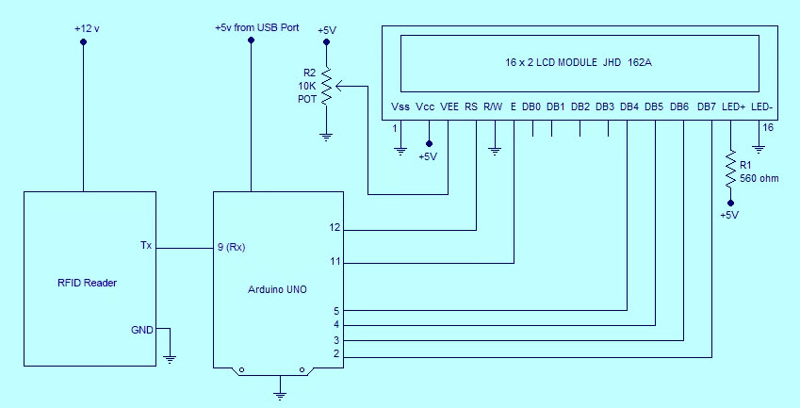

**Fig 3.1.4 Circuit for Interfacing**

The RFID reader is placed on the outside of the door and it is detached from the controller confidentially so no one can avoid the security by breaking open the RFID reader and trying to short circuit the reader. The controller of this project receives serial information from the RFID reader and controls the Door lock and the LED.

So, finally we can conclude that, when the person swipes with right RFID tag, then the access control system will be will be granted. In the same way, when the person swipes with an unauthorized RFID card, then the data will not be loaded and access will be denied.

**BLOCK DIAGRAM OF PROPOSED SYSTEM**

The Thematic Representation of our ‘RFID based Door Locking System’ will as the figure shown below

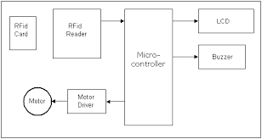

**Fig 3.1.5 Block Diagram**

**CIRCUIT CONNECTIONS**

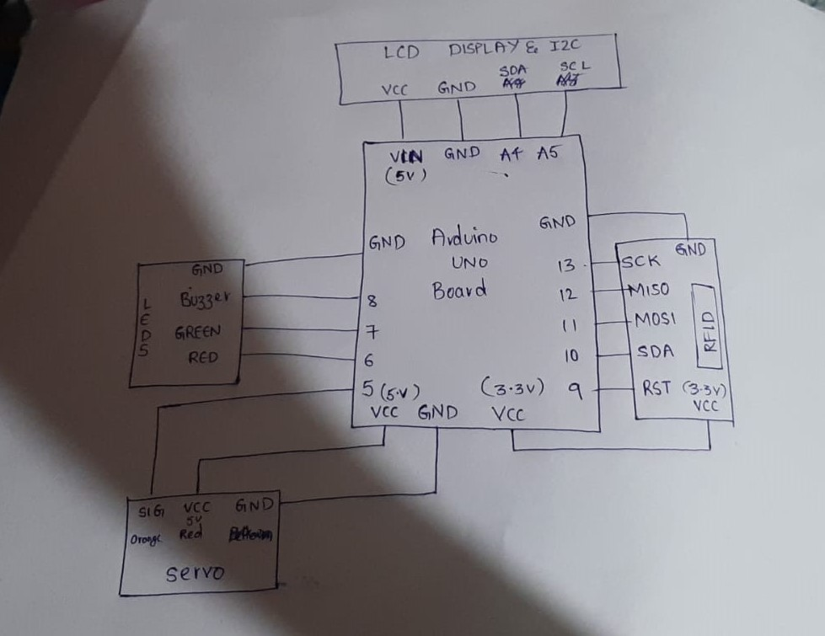

**Fig 3.1.6 Connections**

**FLOW CHART**

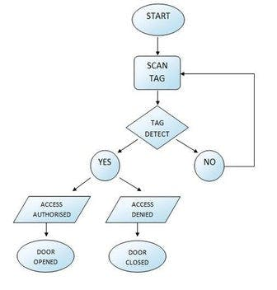

**Fig 3.1.8 Flow Chart**

The above figure shows the flow chart for the implementation of the RFID based Door Locking System. It starts with the reading of the RFID Tag. The Reader starts reading the Tag whenever the Tag is kept in the proximity of the sensor. Whenever the Radio Frequency of the Tag matches with the Reader, then the Access is granted. When there is any difference in Radio Frequencies Access is Denied.

**SIMULATION OF THE PROTOTYPE**

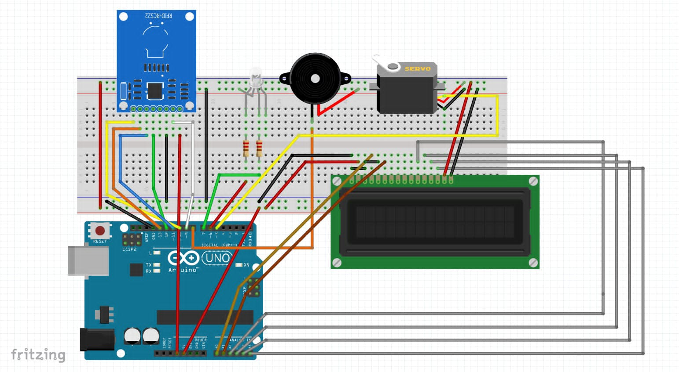

**Fig 3.1.9 Simulation**

The Simulation of our project can be done in online Simulating Tool called Tinker CAD.

It is most likely used for Simulation of various electronic circuits.

The above figure completely shows the connections of our circuit.

**ALGORITHM**

● Connect the circuit as shown in the above fig: Circuit diagram.

● Establish the relation between Arduino and breadboard using USB.

● Store the authorized persons or employee tags in the code by calculating there frequencies through RFID.

● Scan the Tags using RFID readers.

● Each card has a unique ID. Loop through the unique ID bit by bit and verify it with the pre-defined valid tags.

● If any bit mismatches, Break out from the loop and print invalid on LCD screen.

● If all the bits of the unique ID of input card are traversed, then print valid on the LCD screen and open the door.

**3.2 SOURCE CODE**

**Code for including required Header Files:**

#include <SPI.h> //Header File to include Peripheral Interface

#include <MFRC522.h> //to include RFID Module

#define SS_PIN 10 //Setting Pin Positions

#define RST_PIN 9

#include<LiquidCrystal_I2C.h> // Header File to include LCD

LiquidCrystal_I2C lcd(0x27,16,2);

MFRC522 mfrc522(SS_PIN, RST_PIN);

#include<Servo.h> // Header File to include Servos

Servo x;

int pos=0,b=0;

void setup()

{

x.attach(5);

x.write(0);

lcd.begin();

Serial.begin(9600);

SPI.begin();

mfrc522.PCD_Init();

Serial.println("Approximate your card to the reader...");

Serial.println();

pinMode(6,OUTPUT);//red

pinMode(7,OUTPUT);//green

pinMode(8,OUTPUT);//buzzer

lcd.clear();

lcd.setCursor(0,0);

lcd.print("RFID BASED SMART");

lcd.setCursor(1,1);

lcd.print("LOCKING SYSTEM");

delay(2000);

}

void loop()

{

digitalWrite(7,0);

digitalWrite(8,0);

digitalWrite(6,0);

if ( ! mfrc522.PICC_IsNewCardPresent())

{return;}

// Select one of the cards

if ( ! mfrc522.PICC_ReadCardSerial())

{

return;

}

//Show UID on serial monitor

Serial.print("UID tag :");

String content= "";

byte letter;

for (byte i = 0; i < mfrc522.uid.size; i++)

{

Serial.print(mfrc522.uid.uidByte[i] < 0x10 ? " 0" : " ");

Serial.print(mfrc522.uid.uidByte[i], HEX);

content.concat(String(mfrc522.uid.uidByte[i] < 0x10 ? " 0" : " "));

content.concat(String(mfrc522.uid.uidByte[i], HEX));

}

Serial.println();

Serial.print("Message : ");

lcd.clear();

content.toUpperCase();

if (content.substring(1) == "B3 50 08 19"||content.substring(1) == "79 9A 53 2F"||content.substring(1) == "7E 48 D3 0C"||content.substring(1) == "CE 2D DE 0C"||content.substring(1) == "EC 61 67 1D")

{

Serial.println("Authorized access");

Serial.println();

lcd.clear();

lcd.setCursor(1,1);

lcd.print("Access Granted");

lcd.setCursor(5,0);

lcd.print("Welcome");

digitalWrite(7,1);

digitalWrite(8,0);

digitalWrite(6,0);

for (pos = 0; pos <= 180; pos +=1) {

x.write(pos);

delay(10);

}

delay(2000);

}

else {

Serial.println(" Access denied");

lcd.clear();

lcd.setCursor(1,0);

lcd.print("Access denied");

lcd.setCursor(2,1);

lcd.print("Door Locked");

digitalWrite(7,0);

for(b=0;b<5;b++){

digitalWrite(8,1);

digitalWrite(6,1);

delay(300);

digitalWrite(6,0);

digitalWrite(8,0);

delay(300);

}

}

}

**3.2.1 OUTPUT SCREENS**

The connections are made as shown below. The initial set up of the System looks like this.

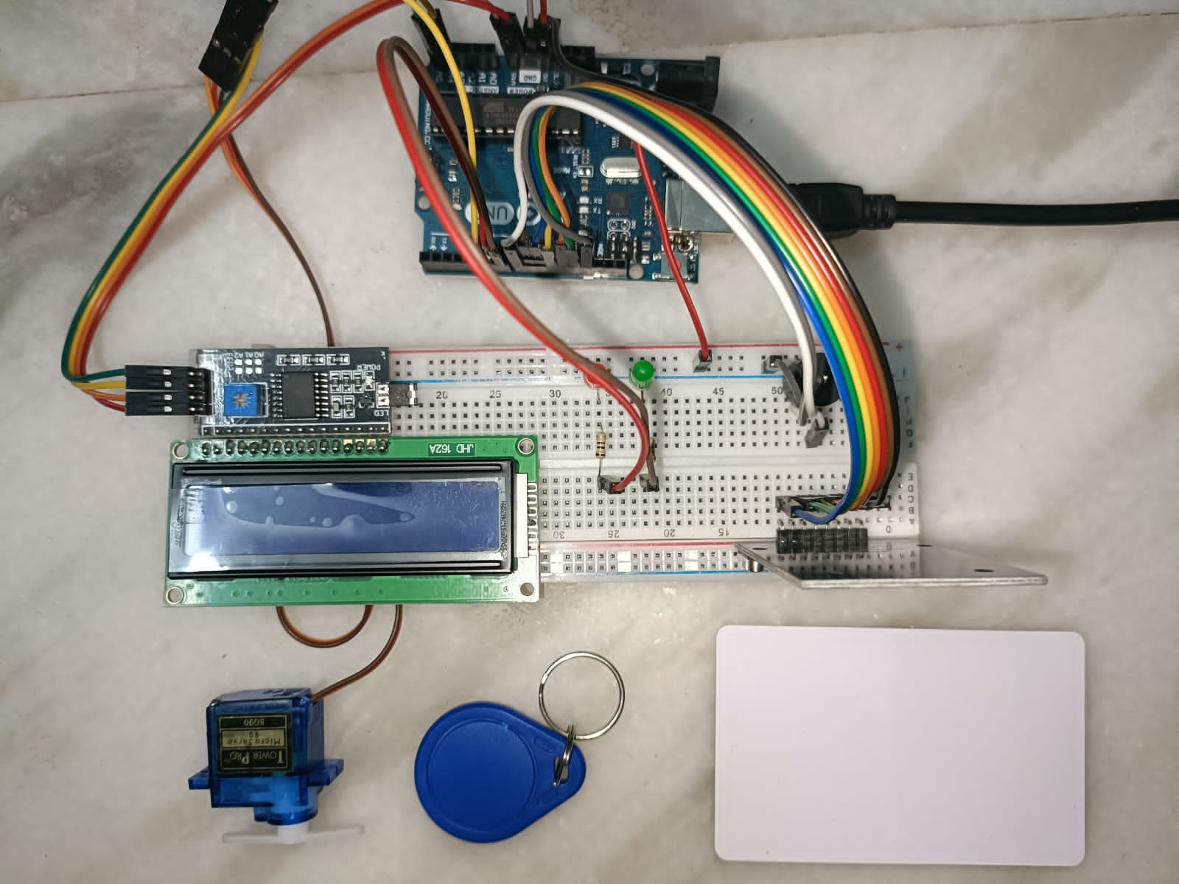

**Fig 3.2.1.1 Project Setup**

When the system is powered through the USB cable, the Whole System looks as shown below

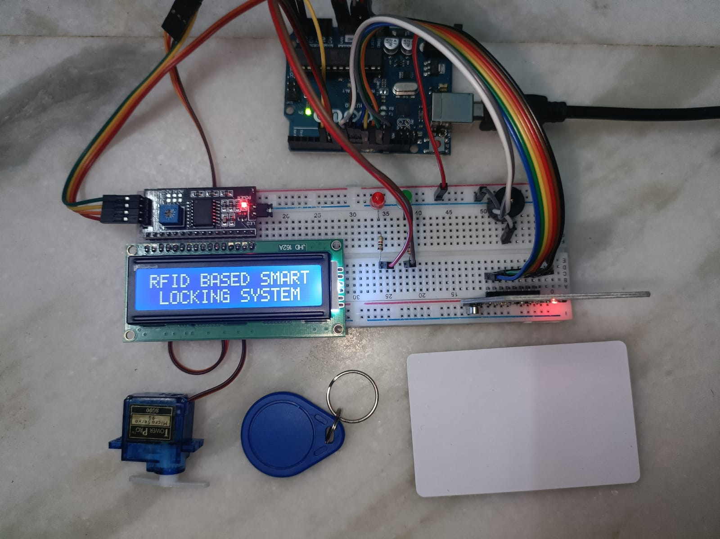

**Fig 3.2.1.2 Initial Screen**

When the valid tag is detected, the LCD displays “Welcome Access Granted” on the display screen and the Servo Motor moves by 180 degree indicating the opening of the door.

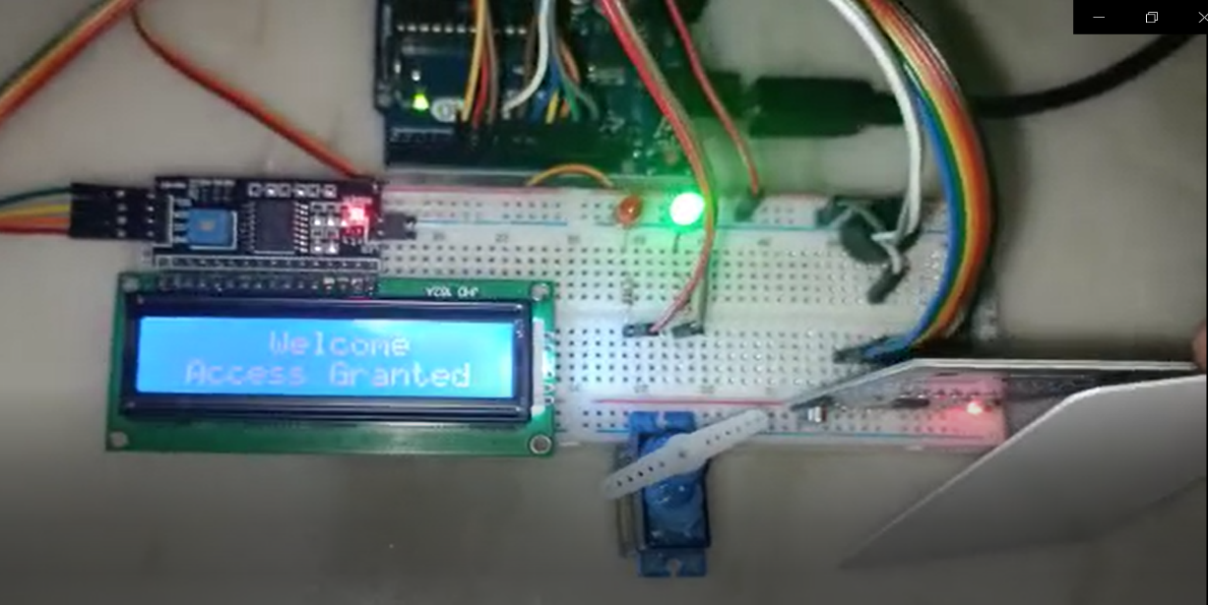

**Fig 3.2.1.3 Output Screen1**

When the valid tag is not detected, the LCD displays “Access Denied. Door Locked” and Servo doesn’t rotate indicating the Door is locked.

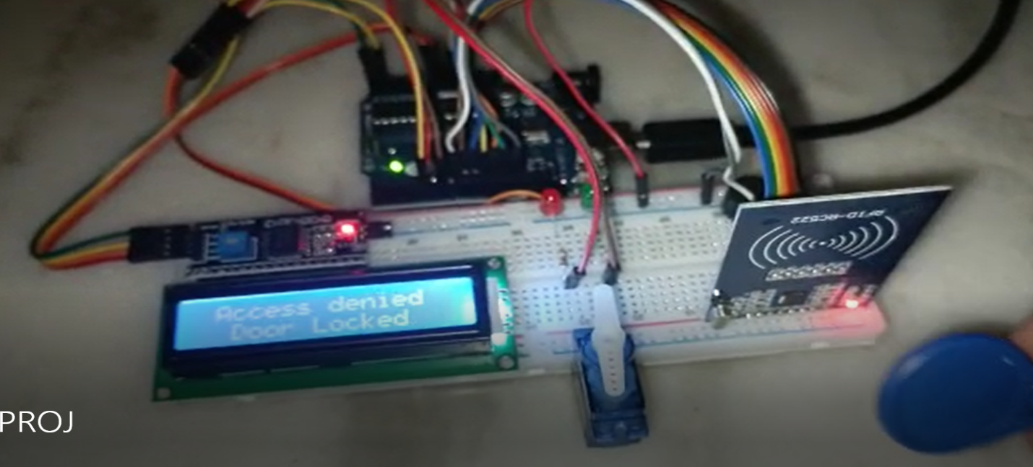

**Fig 3.2.1.4 Output Screen 2**

**4.CONCLUSION**

The RFID Door Lock is a very cheap and affordable design that allows convenience and  
security for users. The design is relatively small and easy enough to install with just a  
couple of screws. The relay supplies the solenoid lock with the power supply if the tag  
read matches with the saved tag in the microcontroller. If the tags do not match then the  
buzzer is activated in the third attempt. In this way the user is allowed or denied access.  
A single 9V power source along with a voltage regulator and an inverting amplifier can  
be used to provide power to both the microcontroller and the solenoid lock. We have  
used an external power source of l8V to provide power to the solenoid lock due to time  
constraints.

**FUTURE WORKS**

There are additional features that can be added in order to improve the system as a whole. However, it is important to note the cost of the improvement should be taken into consideration. The following are a few ideas that can be implemented without adding much cost to the design as a whole. These are just a few of the ideas for the RFID Door Lock in which improvements can be made to further improve both the security and convenience of the product. The first addition is strictly a change in the code. As of now, the RFID reader used is linked to the tag and card reader. However, either by adjusting the code or using a different RFID reader, one should be able to read the RFID code of the individual tags and cards. This will allow for more options in terms of how the user wants the security to be set up. By reading the specific RFID codes, you can change the accepted keys and also deny access for certain keys. Another additional addition code is responses to potential brute force. A common technique in which people use to hack digital door locks is using a variable RFID card that changes its pattern rapidly until it finds the correct pattern. To counter this, you can implement a response from the Arduino if the wrong RFID pattern is read more than X amount of times. For example, you can stop accepting any patterns after X amount of times or require a reset in order to unlock the door. An example of a physical improvement is adding the ability to run on 9V batteries. This gives albeit a limited amount of security in case of a power outage. Because of the inverting amplifier design, even when disconnected with the Arduino, the door lock has the ability stays locked. But in order for the door to stay locked, it still needs a power supply. If the door is powered by a 9V power supply when disconnected from the power supply, you can keep the door locked and that’ll give the owners time to respond before they’re house is left unprotected. With 9V batteries, Arduino should be capable of being powered as well allowing the correct RFID card to still unlock the door.

**REFERENCES**

1. www.security.honeywell.com
2. https://searchsecurity.techtarget.com
3. www.vectorsecurity.com
4. https://www.elprocus.com/automatic-door-lock-system-using-RFID-and-arduino/
5. https://www.slideshare.net/naveeniift/RFID-and-its-applications
6. www.fibre2fashion.com/industry-article/3271/RFID-applications
7. <https://blog.atlasRFIDstore.com/>
8. V. Subramanian, P. C. Chang, D. Huang, J. B. Lee, S. E. Molesa, D.

R. Redinger, and S. K.Volkman, "Printed organic transistors forultra-lowcostRFID applications", IEEE Transactions on Components and Packaging Technologies, 2005

1. https://www.hackster.io/user8523373/RFID-based-automatic-door-system-7b2065
2. https://www.arduino.cc/
3. www.camcode.com/asset-tags/what-are-RFID-tags/
4. www.camcode.com/asset-tags/what-are-RFID-tags/
5. https://en.wikipedia.org/wiki/Buzzer
6. https://circuitdigest.com/article/servo-motor-basics
7. https://en.wikipedia.org/wiki/Light-emitting_diode
8. https://en.wikipedia.org/wiki/Jumper_cable
9. A. JuelsRFID security and privacy: A research survey IEEE Journal on chosen areas in Computing, 24(2):381–394, February 2006.
10. M. R. Rieback, B. Crispo, and A. S. Tanenbaum, "The Evolution of RFID Security"; PervasiveComputing, IEEE Volume 5, Issue 1, Jan.- Mar. 2006.
11. Kamran Ahasan, Paul Kingston IEEE paper on “RFID applications: an introductory and exploratory study”.
12. <https://www.arduino.cc/en/main/software>
13. Mandeep Kaur, Manjeet Sandhu, Neeraj Mohan and Parvinder S. Sandhu'RFID  
    Technology Principles, Advantages, Limitations & lts Applications'  
    Intemational Joumal of Computer and Electrical Engineering, Vol.3, No'l'www.elprocus.com/understanding-about-types-of-access-control-systems/